International Consultant Certification (ICC)
Two Day Program

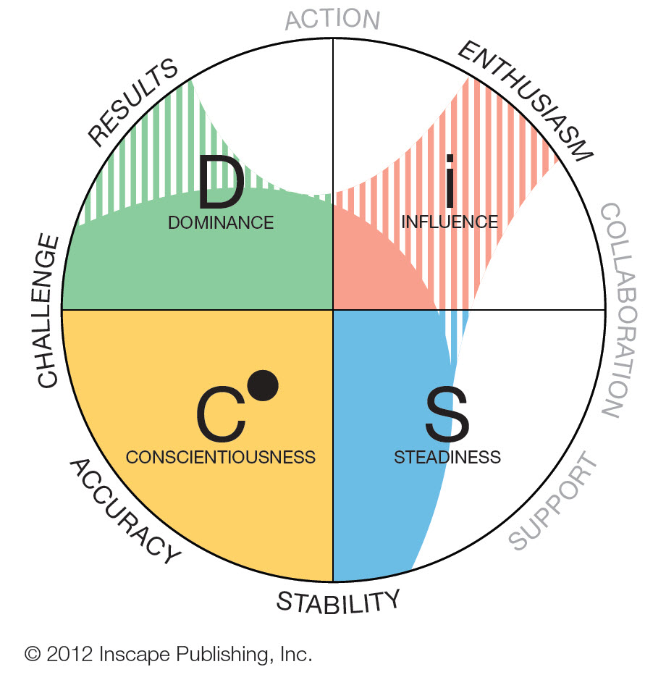

is 2015 Wiley Diamond Award winning partner——TOP 1 in the Greater China and Top 1% Globally, and has accredited the most Everything DiSC® Certified Consultants in Greater China

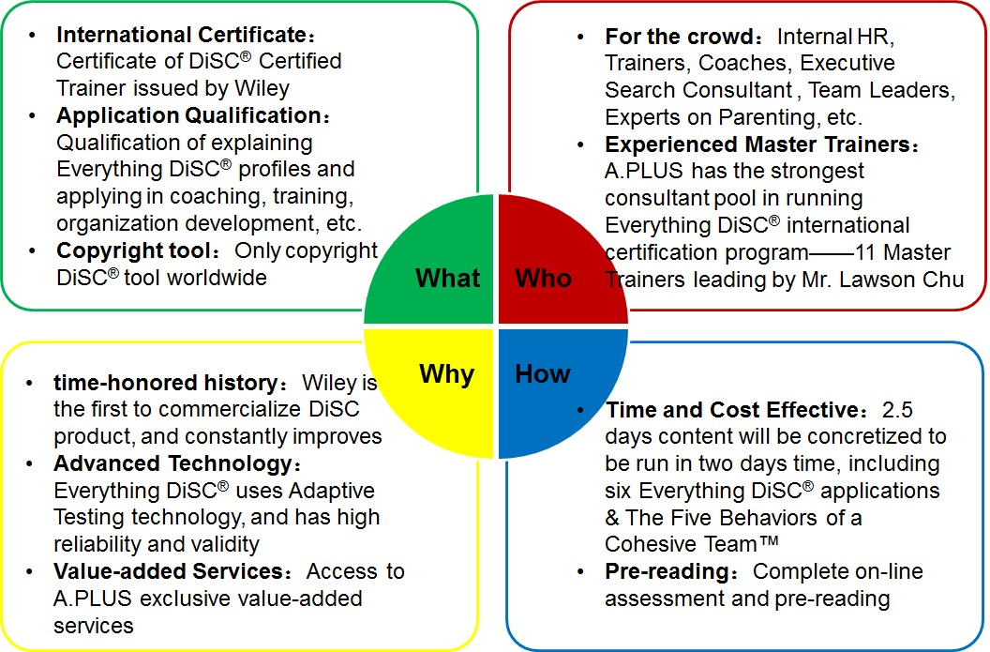

is a global publishing company that specializes in academic publishing and markets its products to professionals and consumers, students and instructors in higher education, and researchers and practitioners in scientific, technical, medical, and scholarly fields. The company produces books, journals, and encyclopaedias, in print and electronically, as well as online products and services, training materials, and educational materials for undergraduate, graduate, and continuing education students.

What is Everything DiSC® Certification?

A.PLUS is the authorized partner of Wiley Everything DiSC® and The Five Behaviors of a Cohesive Team™ serving one stop psychological profiling, certification and application service in Mainland China, Hong Kong, Taiwan and Macau in one go. A.PLUS holds Everything DiSC® International Consultant Certification (ICC) in Beijing, Shanghai, Shenzhen, Hong Kong, Taipei and Macau.
By completing Everything DiSC® International Consultant Certification and passing the final exam successfully, you will become Everything DiSC® certified consultant and receive the certificate of DiSC® Certified Trainer issued by Wiley. You will have the qualification of explaining Everything DiSC® profiles or applying them in coaching, training, organization development, etc.
DiSC® & Everything DiSC® both are Wiley's registered trademarks. Wiley’s DiSC® products are used in over 70 countries by more than 45 million people, and has been recognized by many of the Fortune 500 companies

Everything DiSC® Certification includes:
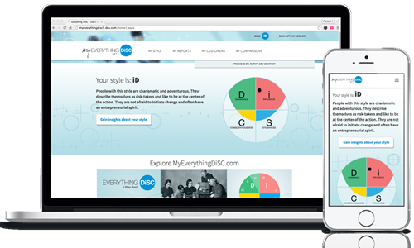
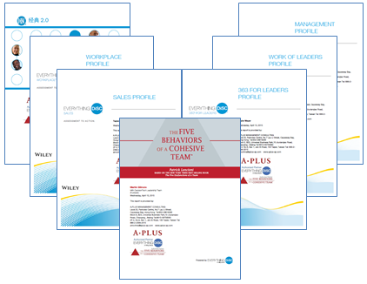

- History of DiSC®
- DiSC® theory and model
- DiSC® reliability and validity
- Application I: | Everything DiSC® Workplace - Productivities Enhancement for all Jon nature and ranking
- Application II: | DiSC® Classic 2.0 - the classic series with line graph presentation, and still popular in the market
- Application III: | Everything DiSC® Sales - new technology to facilitate sales to connect various clients
- Application IV: | Everything DiSC® Management - comprehensive approach to unleash staff’s potentials
- Application V: | Everything DiSC® Work of Leaders - Simple but not Simplistic approach for leaders keep on improving with VAE model - Vision, Alignment, Execution
- Application VI: | Everything DiSC® 363 for Leaders - the combination of 360° assessment and Everything DiSC®，with 3 strategic advices for leadership enhancement
- Application VII: | The Five Behaviors of a Cohesive Team™ - the result of the partnership between Wiley Workplace Learning Solutions and best-selling author Patrick Lencioni’s “The Five Dysfunctions of a Team”
- Massive follow-up resources: | Comparison Report, Group Culture Report, Customer Interaction Map, Facilitation Kit, MyEverythingDiSC.com, etc.
- One-on-one coaching & Giving feedback
- Practice as a facilitator
- Written exam

Why A.PLUS Everything DiSC® Certification
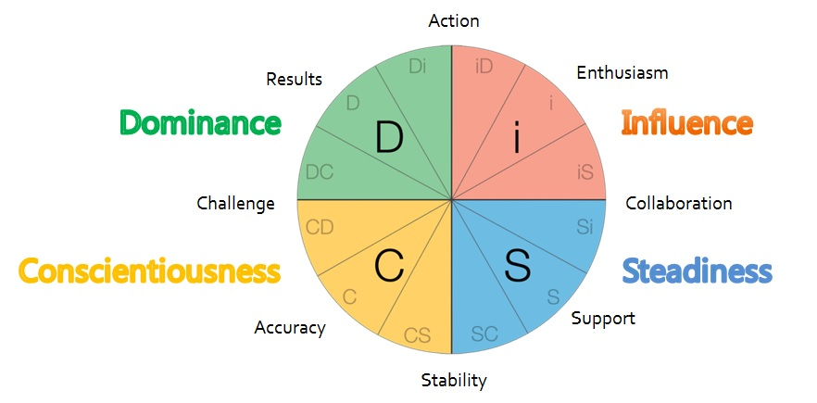
- Advanced and practical tool：DiSC® assessment is based on the behavioral theory stated in William Moulton Marston’s book called “Emotions of Normal People” which was written in 1928, and helps individuals, teams and organizations make the transition by helping people develop deeper understanding of themselves and interrelationships. Wiley is one of the largest global academic publishers established in 1807 with more than 5000 employees worldwide. Wiley is the first to commercialize DiSC products and constantly improves. Everything DiSC®, the new generation of DiSC®, uses the advance technology of Adaptive Testing, and has high reliability and validity. Its profiles provide more practical and personalized information, and could assist the transition from assessment to action.

- Exclusive value-added services： Everything DiSC® experiential activity guidebook, presentation PPT that could be used in training, A.PLUS exclusive value-added service USB, Wiley and A.PLUS membership, 10% off for purchase of any profiles and facilitation kit (valid for 1 week after the facilitation program) and 20% off for joining Everything DiSC® public courses.

Who are in charge of Everything DiSC® Certification

A.PLUS is the authorized partner of Wiley Everything DiSC® and The Five Behaviors of a Cohesive Team™ covering Mainland China, Hong Kong, Taiwan and Macau in one go. A.PLUS has the strongest consultant pool in running Everything DiSC® international certification program, and 11 master trainers are led by Mr. Lawson Chu. Mr. Lawson Chu is the expert in applying psychological and behavioral tool in Asia Pacific, and the first international trilingual (English, Mandarin & Cantonese) accreditation examiner of MBTI® with rich experience in psychological and behavioral tools certification.

Who would benefit from Everything DiSC® certification program?

Team Managers, HR Professionals
- Discover how Everything DiSC® Certification, this 21st century tools helps you provide greater appreciation for diverse approaches and improved organizational success to the individuals and groups you work with.

Trainers, Educators, Coaches
- Find out how Everything DiSC® Certification can improve your teaching and training performance by discovering how people's natural preferences impact their learning and personal development. Also it gives you a proven method for helping your clients gain self-understanding and healthy psychological development.

Consultants, OD Professionals
- Learn how Everything DiSC® Certification can help boost your skills and your career, whether you are an independent consultant or an in-house professional.
- ……
Requirement: Bachelor Degree holder, or 3 years working experience in relevant area of HR, Training, Academic, Coaching or relevant fields. Basic Proficiency in reading English

Who has been certified by A.PLUS & Wiley

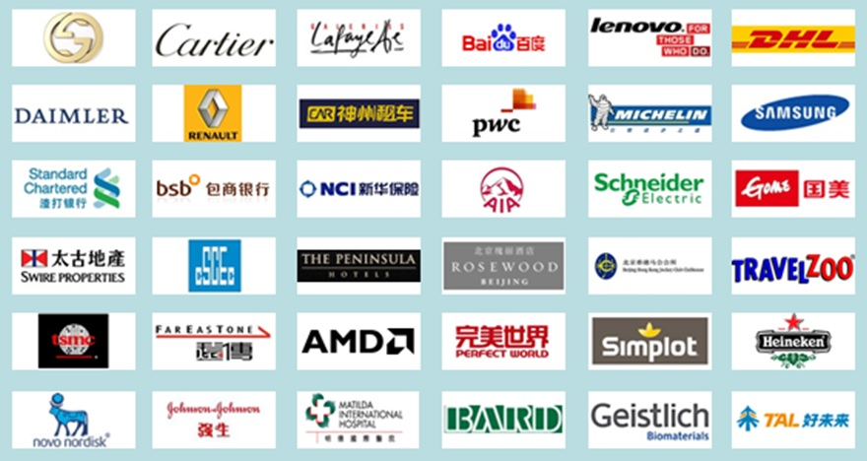

How to join Everything DiSC® Certification

2016 Everything DiSC® Certification Schedule: Time: 0830-1800
Location | Course No | Date | Language
Beijing | 1601 | 2016.01.21-22 | Mandarin
 | 1604 | 2016.03.24-25
 | 1606 | 2016.05.12-13
 | 1610 | 2016.06.23-24
 | 1611 | 2016.07.28-29
 | 1612 | 2016.09.08-09
 | 1616 | 2016.10.27-28
 | 1620 | 2016.12.08-09
Shanghai | 1605 | 2016.04.09-10 | Mandarin
 | 1617 | 2016.11.12-13
Shenzhen | 1607 | 2016.05.21-22 | Mandarin
 | 1618 | 2016.11.26-27
Hong Kong | 1602 | 2016.03.10-11 | Cantonese
 | 1608 | 2016.06.02-03
 | 1614 | 2016.09.22-23
 | 1619 | 2016.12.01-02
Taipei | 1603 | 2016.03.17-18 | Mandarin
 | 1609 | 2016.06.07-08
 | 1613 | 2016.09.13-14
 | 1621 | 2016.12.13-14
Macau | 1615 | 2016.10.22-23 | Cantonese

2016 Everything DiSC® Certification Fee
Certification fee includes:
- Chinese notebook and examination materials
- 2 Everything DiSC® Workplace assessment (one for participant to be completed before certification program; another one for participant’s coaching practice)
- Rental of venue, lunch and coffee break
- Everything DiSC® International Consultant Certification by Wiley (Participant has to fully attend 2-day course and pass examination)

 | Original | Special | Early bird discount (complete enrolment and payment 1-month in advance);  Group discount (Group enrolment with 2 or above)
2 Days Certification | HKD 15,000/Person | HKD 12,000/Person | HKD 10,800/Person
2 Days Certification Program +Everything DiSC® Workplace Facilitation Kit  Package | HKD 24,975/Person | HKD 20,500/Person | HKD 19,300/Person

If you need more information, please contact us:

Hong Kong
Level 20, Parkview Centre, No.7 Lau Li Street, Causeway Bay, Hong Kong
Tel：852-3709 8290 Email:amcap@aplus-ap.com

Beijing
Block E, B23, Uniersal Business Park,10 Jiuxianqiao Road,Chaoyang Beijing, PRC. Zip code: 100015
Tel: 86-10-59756065 Email: amcchina@aplus-ap.com Fax:86-10-59756063

Shenzhen
401E, Tongsheng Technology Building, Huahui Road, Dalang Street, Longhua New District, Shenzhen
Tel: 0755-23779772 Email: amcchina@aplus-ap.com

Taipei
2F-2, No. 6, Sec. 1, Jen-Ai Road, 100 Taipei, Taiwan
Tel: 886-2-23942015 Email: amc@aplus-ap.com

Macau
5/F of FIT Centre Macau, Ave. Commercial de Macau
Tel: 853-2827 1068 Email: amc@aplus-ap.com

